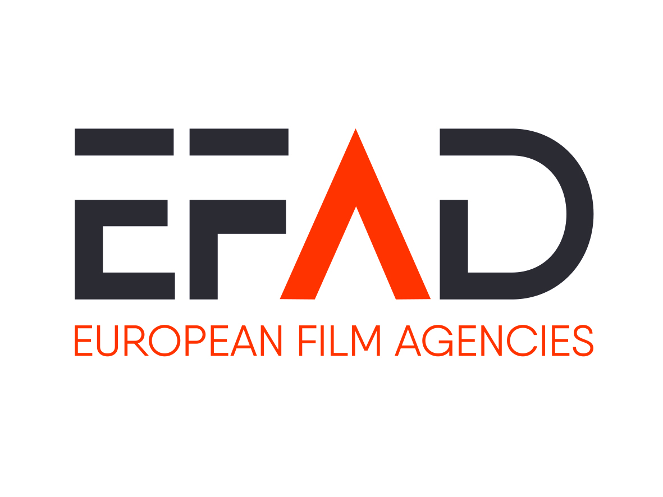
EFAD EU Policy and Strategy Working Group
Brussels, Tuesday 19 Novembre 2019, 9:00-13:00

Draft minutes

- Updates on Copyright Reform and AVMS directive

  - Review of the Geoblocking Regulation

      - Next step: organize a meeting with Thierry Breton’s Head of Cabinet early 2020 to find out more about the Commission’s plans

  - Transposition of the DSM Directive – State of play in Member States and on EU Level
      - Next step: continue to collect of information about the transposition process in the different countries

  - Transposition of SatCab Directive – State of play in Member States

      - See above
      - Need to monitor the definition of news and current affairs

  - Sky Case

      - Next steps: Board to decide on participation in an oral hearing (now confirmed for the 6 February 2020)

  - Digital Services Act

Lack of clarity about the timing, scope and relevance for the audiovisual sector of this initiative.

      - Next steps: wait and see, no pro-active action at that stage

  - AVMSD

Background information:
- Final Guidelines for the transposition of art. 13 still not on the table

Next EFAD steps: meeting with AVMSD unit to clarify further roadmap or open questions (see report)

- Creative Europe MEDIA
  - Update on the negotiations of the new programme and on new actions suggested by the EFAD: European Writer’s Rooms, MyEuropeanFilmFestival

- Next EFAD steps: exchange with MEDIA Unit (see report)

- Strengthening the independent European film industry
  - Summary of first results of the EFAD questionnaire

Background information:
First results, based on answers from 10 EFAD members:
Several countries (seven out of ten) have national definitions of what constitutes an "independent producer", two countries define "independent works". Only in Spain there is a definition in place for film theatres and distributors. The production sector is the key area of definitions and supporting instruments.
The discussion focused on:
- The definition of independent producer: there is no clear picture as to the advantages / disadvantages of an EU-wide definition and several EFAD members think this questions needs a deepened discussion.
- The need to concentrate the discussion on production or other industry sectors, considers that the challenges at stake are very different
Promoting the independent sector is in several countries embedded into the funding policy or regulation (ie. Investment obligations). It is also connected to the capacity for independent producers to keep rights when negotiating with the platforms.

Next to terms of trade with broadcasters there are hardly any industry initiatives to strengthen the independent film sector and there are no alternative financing sources designed for the independent film industry.
Next to reporting on the transposed AVMSD, there are no other regular monitoring / evaluation tools in place to investigate the situation of the independent film sector.

  - Discussion on EFAD’s focus and on next steps

The working group decided to work on guiding questions for the further discussion. These should be problem-oriented. There is also a need to clarify the expected outcome of this reflection process.

Next steps: Julia and Neil will work on concrete, problem-based questions for further discussions.

- Environmental issues
  - Mapping of environmental promotion initiatives taken by Film Funds

Julie-Jeanne distributed a summary of the main ongoing green initiatives both from the private and public sectors.

Tim Wagendorp (VAF) was invited as a guest expert on green screen and green filming initiatives carried out by regional film funds in Europe. He informed about the“Green screen” project funded by Interreg) working on green filming strategies based on experiences from pioneers on the field. The objective of this network is to strengthen the awareness of the film industry, to coach film industry professionals, and to implement initiatives thoroughly.

The working group discussed the values and limits of an EFAD’s activity on this field. It was agreed that the EFAD should engage to:

- bring together the green experts within the EFAD and join the Cine-Regio working groups
- map the current and envisaged national film funds initiatives and identify best practices, with regular updates on the EFAD website
- reflect on recommendation for EU action (MEDIA)

- Trade Issues – postponed due to time limits
  - Discussion on possible Coproduction Agreement EU-Australia
  - Future of Protocol on Cultural Cooperation between the EU and Korea

- New European Parliament and European Commission – postponed due to time limits
  - Exchange of information on key MEPs and Commissioners
  - Information on the EFAD-meetings on November 20th (schedule to follow)

- EU presidencies activities – postponed due to time limits
  - Feedback on Finish Presidency conference in September
  - Outlook on Croatian Presidency
  - Outlook on German Presidency

- AOB – postponed due to time limits

