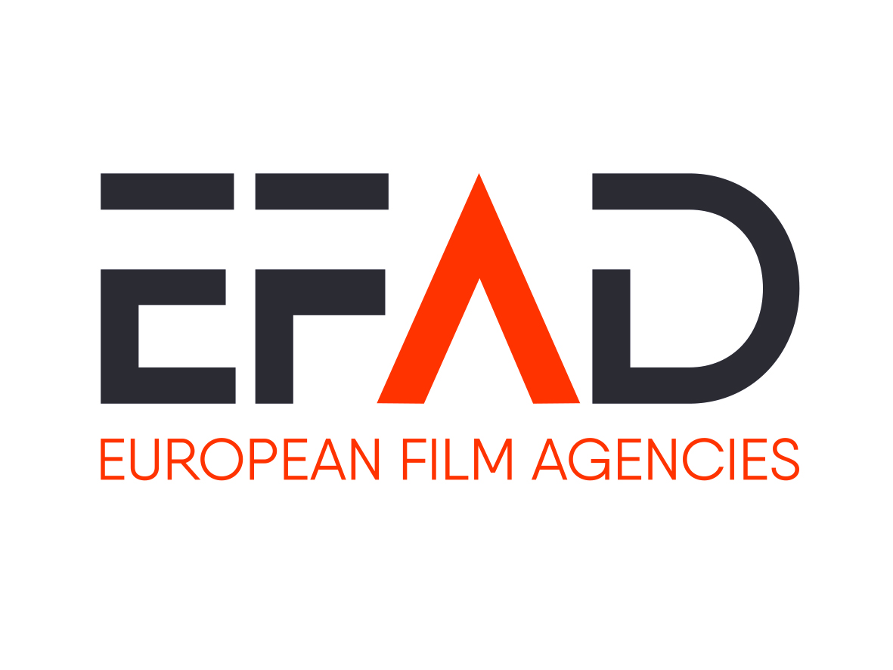

EFAD EU Policy and Strategy Working Group
Brussels, Tuesday 19 November 2019, 9:00-13:00

Location: À la Maison européenne des Auteurs et des Autrices
Rue du Prince Royal 85-87, 1050 Bruxelles

Draft agenda

- Updates on Copyright Reform and AVMS directive
  - Review of the Geoblocking Regulation
  - Transposition of the DSM Directive – State of play in Member States and on EU Level
  - Transposition of SatCab Directive – State of play in Member States
  - Sky Case
  - Digital Services Act
  - AVMSD

- Creative Europe MEDIA
  - Update on the negotiations of the new programme and on new actions suggested by the EFAD: European Writer’s Rooms, MyEuropeanFilmFestival

- Strengthening the independent European film industry
  - Summary of first results of the EFAD questionnaire
  - Discussion on EFAD’s focus and on next steps (handout to follow)

Coffee Break

- Environmental issues
  - Mapping of environmental promotion initiatives taken by Film Funds

- Trade Issues
  - Discussion on possible Coproduction Agreement EU-Australia
  - Future of Protocol on Cultural Cooperation between the EU and Korea

- New European Parliament and European Commission
  - Exchange of information on key MEPs and Commissioners
  - Information on the EFAD-meetings on November 20th (schedule to follow)

- EU presidencies activities
  - Feedback on Finish Presidency conference in September
  - Outlook on Croatian Presidency
  - Outlook on German Presidency

- AOB

